

**Xite***Solutions*

North America Inc

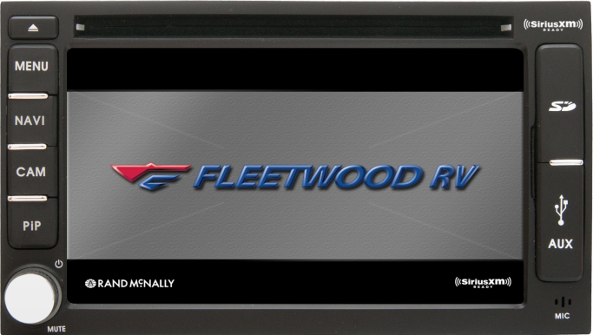

**XSG2NA-X1S 6” Infotainment System**

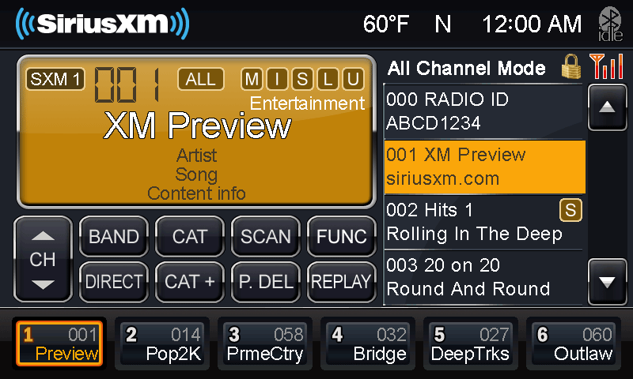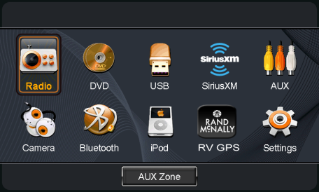****

**X1S Features**

* 6” Touch Screen Display
* Rand McNally RV GPS
* 7” Passive Monitor (Optional)
* Temperature/Compass Display (Optional)
* iPod and iPhone Audio playback
* SiriusXM - SXV200 Tuner
* GPS System Clock/DST/TZ set
* Front access DVD/CD/USB and 3.5mm audio inputs
* House Mode Audio Distribution (Optional)
* Touch Screen Multi Camera Management with CVS Module
* Split Screen (PIP) Operation
* Camera Audio/Video Support
* Quick Camera View Button
* Integrated Bluetooth for HF calling, stream audio from device and many app sources
* Aux Output for Entertainment Sources
* AM/FM with RDS