

**Xite***Solutions*

North America Inc

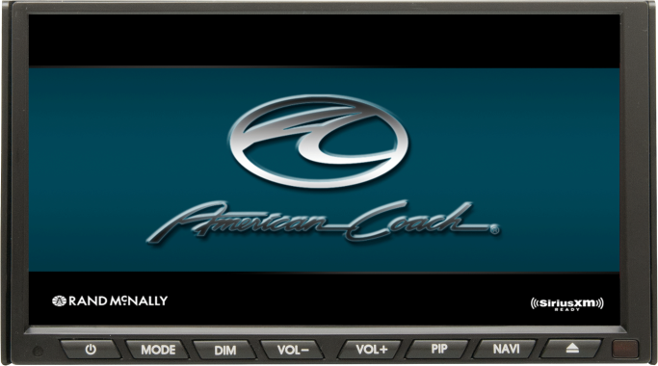

**XSG2NA-X1 7” Infotainment System**

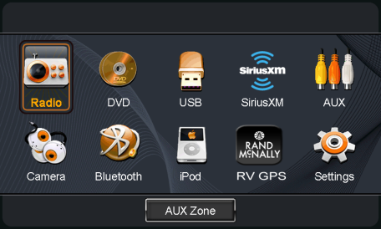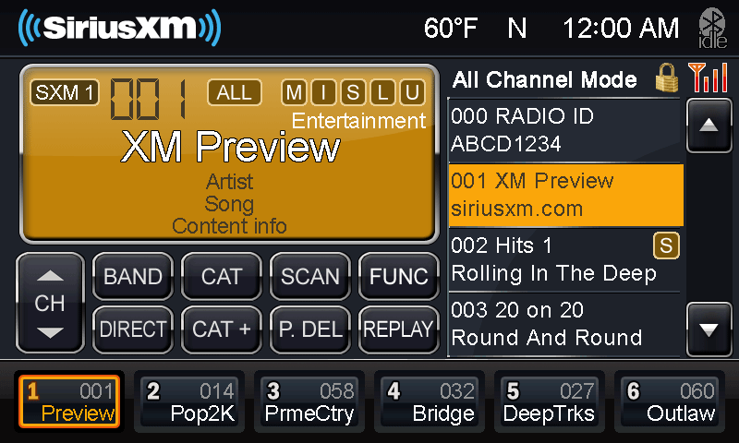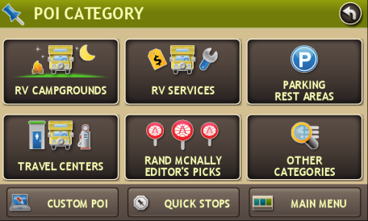

**X1 Features**

* Touch Screen Multi Camera Management with CVS Module
* Split Screen (PIP) Operation
* Camera Audio/Video support
* Integrated Bluetooth for HF calling, stream audio from device and many app sources
* Aux Output supporting Navigation and Camera display
* AM/FM with RDS
* 7” Touch Screen Display
* Rand McNally RV GPS
* 7” Passive 2nd Monitor (Optional)
* Temperature/Compass Display (Optional)
* iPod and iPhone Audio playback
* SiriusXM - SXV200 Tuner
* GPS System Clock/DST/TZ set
* DVD/CD/USB
* House Mode Audio Distribution (Optional)